PLACES TO VISIT
(see map “Western Desert”)

1. SIWA OASIS

The Siwa oasis is a 82 x 28 km big depression in the northwest of Egypt close to the Libyan border. Its population is of mainly berber origin and up to now people speak their own dialect of the Berber language called Siwi. The oasis was always very isolated and therefore developed its very own culture including unique handicraft.

Sightseeing

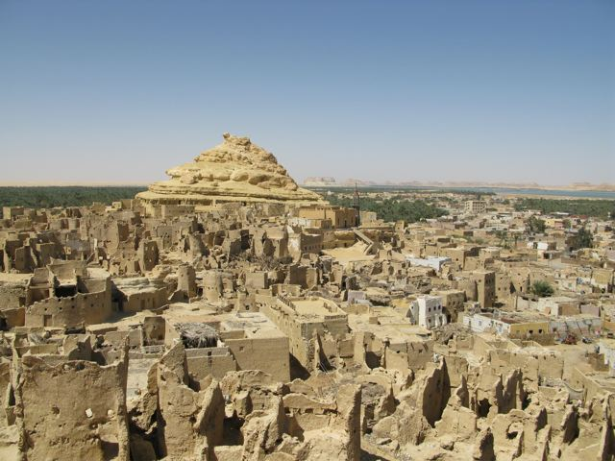 Shali: Old Town of Siwa dating from 13th century
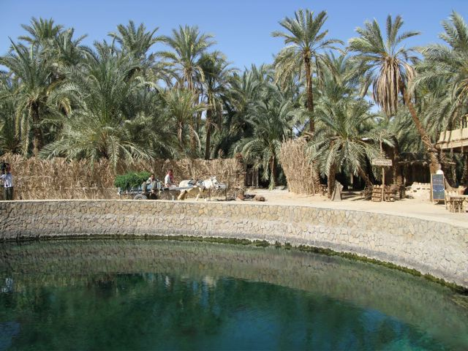 Cleopatra’s Bath: Famous natural spring (swimming possible)
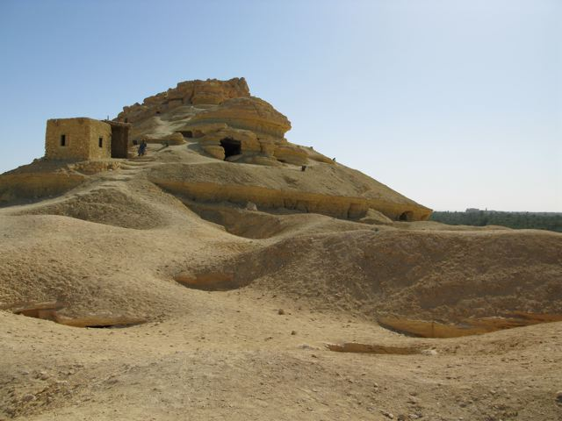 Tombs of Gebel Mawta: A hill full of tombs of the 26th dynasty and later, some of them painted
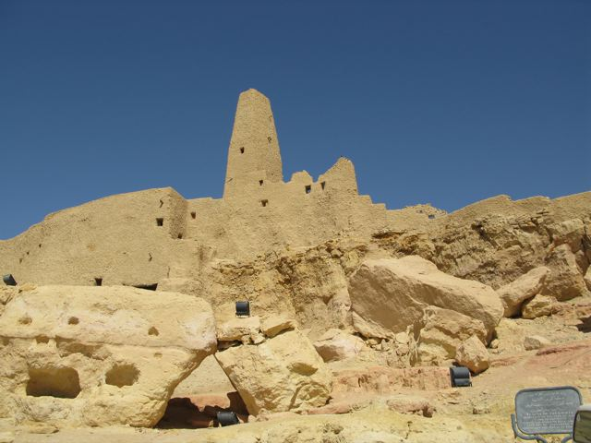 Aghurmi: Old Town of Siwa until the 13th century
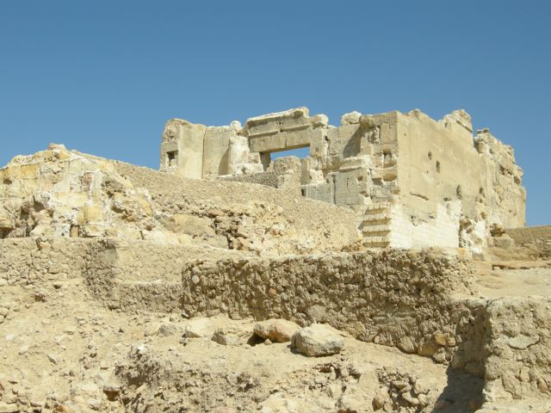 Temple of the Oracle: The famous oracle of Amun that was visited by Alexander the Great
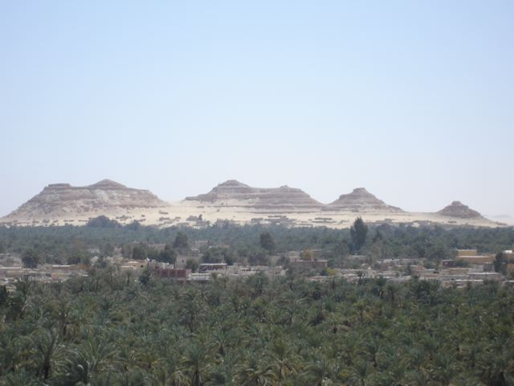 Gebel al Dakrur: Moutain that is famous for its sand cures against rheumatism and arthritis
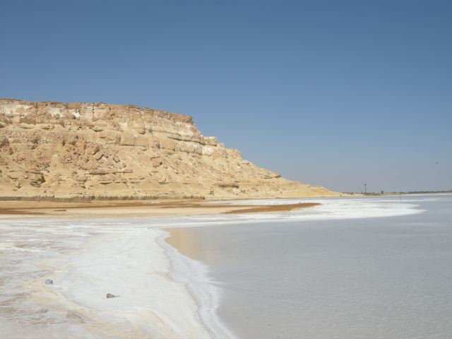 Salt Lakes
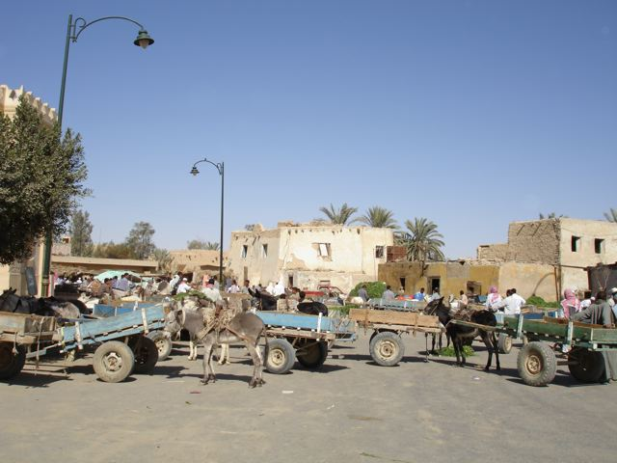 Market

Siwa House: Museum about the way of life and the traditions of the oasis
2. GREAT SAND SEA (Over-day trip from Siwa)

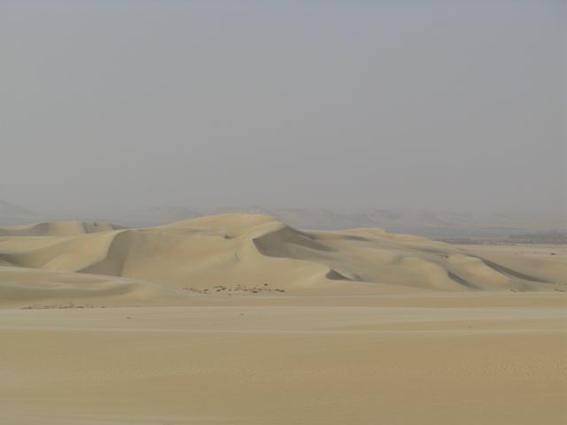 Dunes
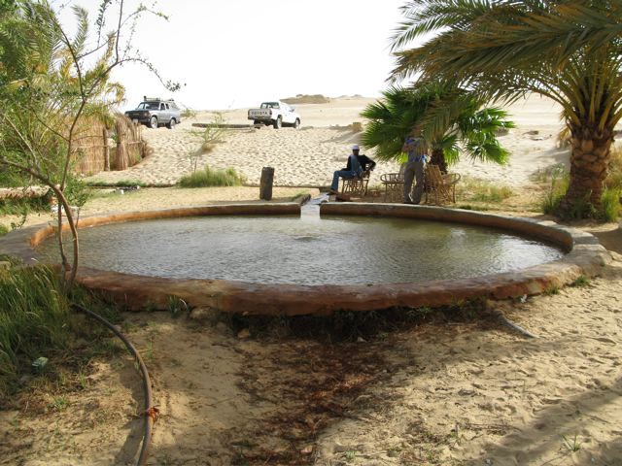 Bir Wahid: Hot Spring in the dunes of the Great Sand Sea (swimming possible)
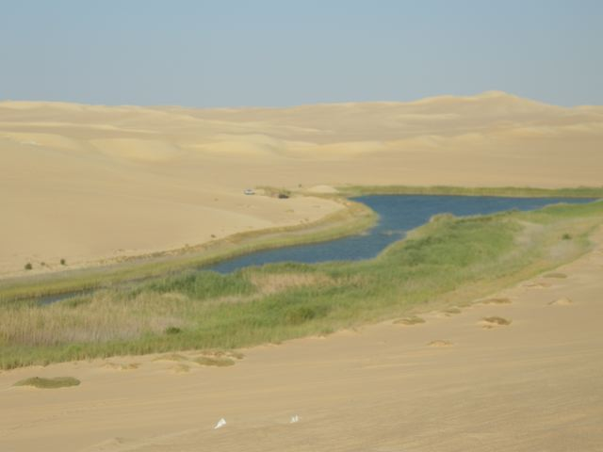 Cold Spring: Right next to the Hot Spring (swimming possible)

3. GREAT SAND SEA and WESTERN WHITE DESERT

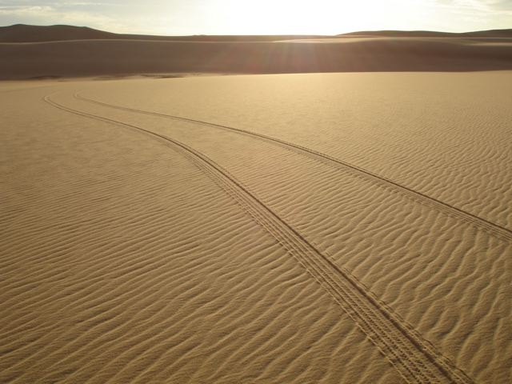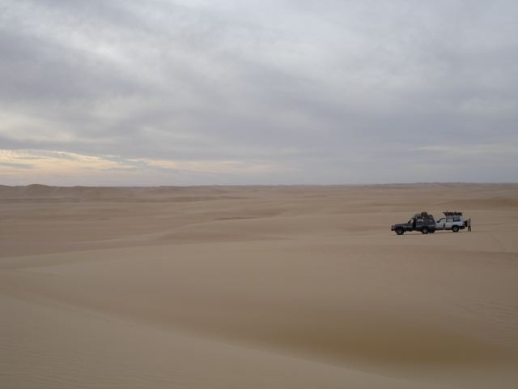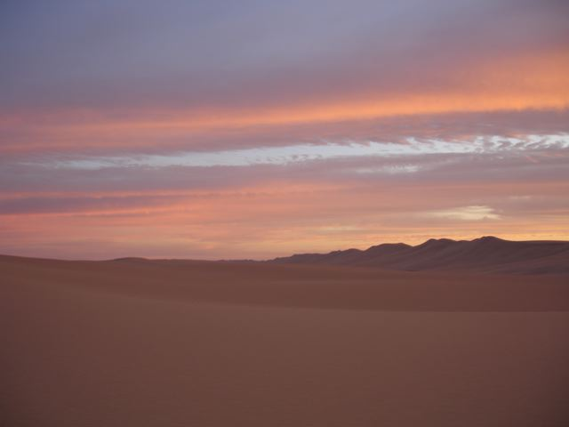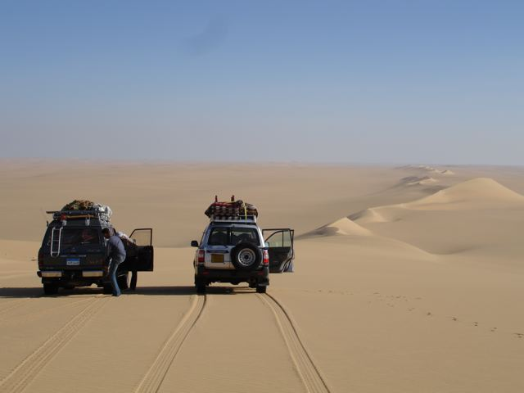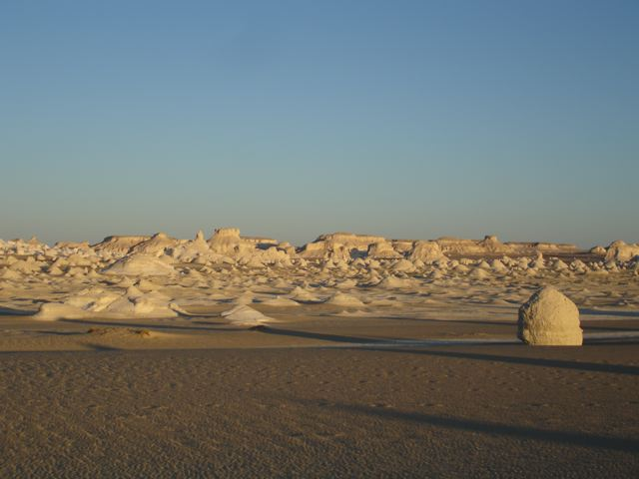

550 km of endless dunes and finally the Western White Desert with its famous limestone formations

4. BAHARIYA OASIS

The Bahariya Oasis is a 94 x 42 km big depression 360 km southwest of Cairo. From the time of the Middle Kingdom it started to be an important agricultural centre.

Sightseeing

Museum of the Golden Mummies: Mummies dating from the Greco-Roman Period (discovered 1996)

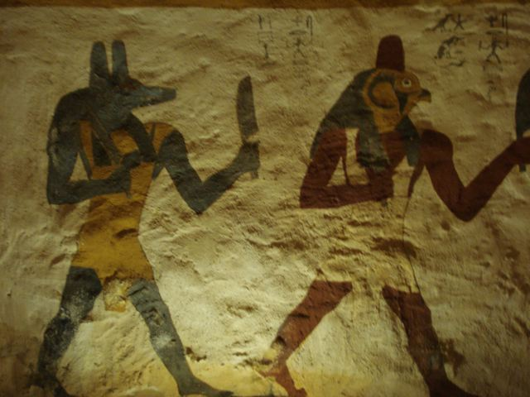 Qaret Qasr Selim: Painted tombs of Zed-Amun-ef-Ankh and his son Bannentiu (26th dynasty)
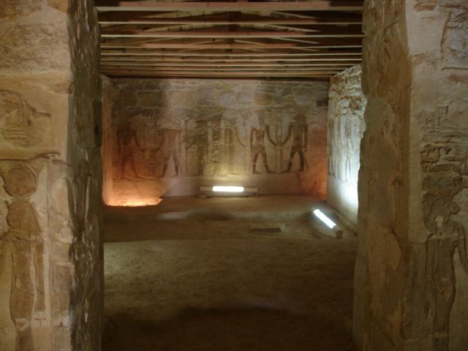 Temple of Ain Muftilla: Four chapels from the 26th dynasty (pharao Amasis)
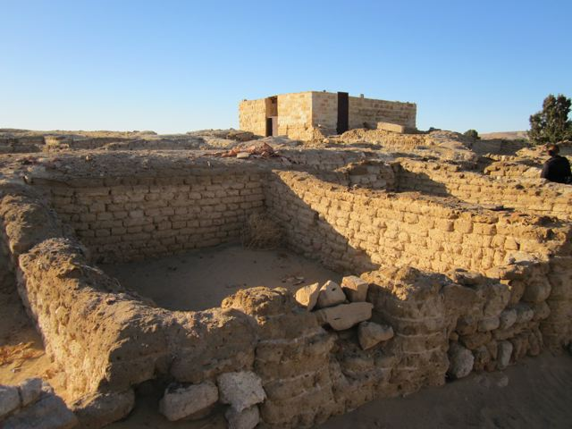 Temple of Alexander the Great: Only evidence of Alexander’s presence in Egypt (331 BC)
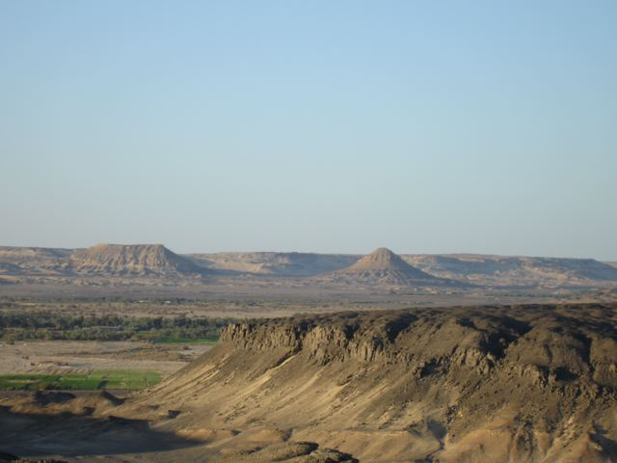 Gebel Ingliz, Gebel Maghrafa, Gebel Dist: Famous mountains of the oasis
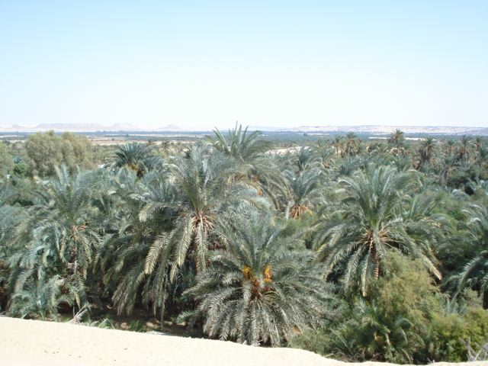 Palm Gardens
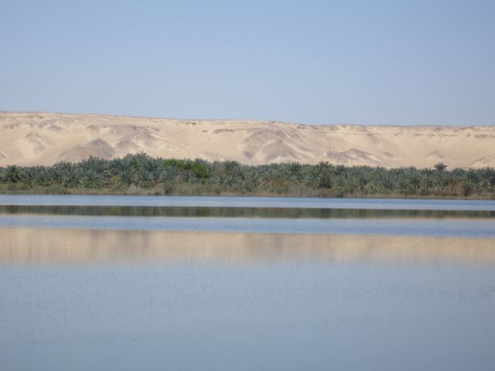 Salt Lake

5. BLACK DESERT

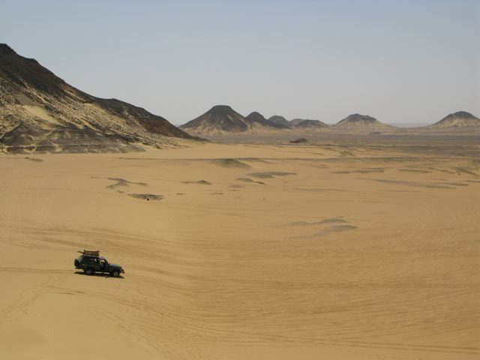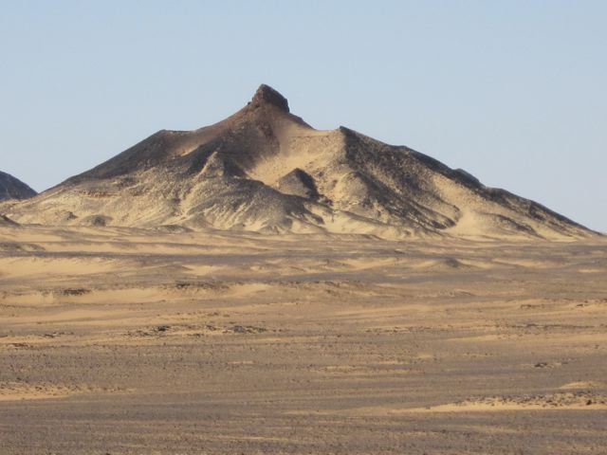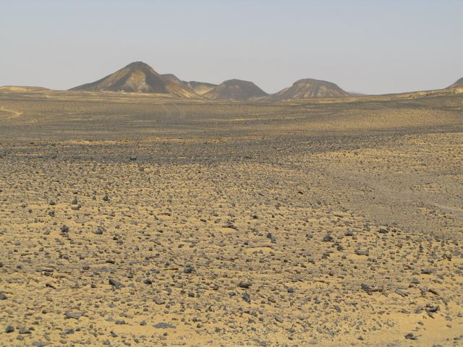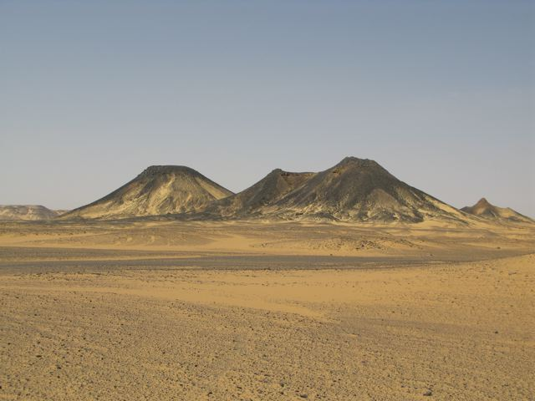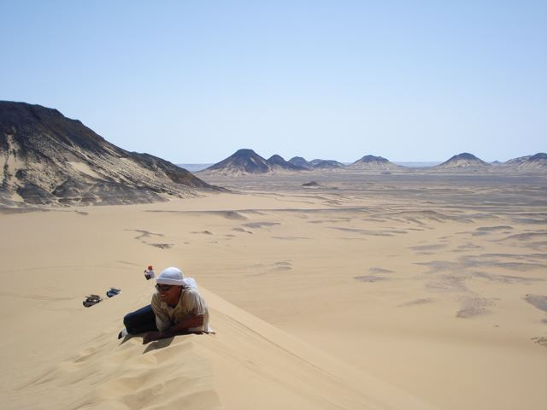

The Black Desert in the south of the Bahariya depression with its impressing basalt rock hills.

6. WHITE DESERT NATIONAL PARK

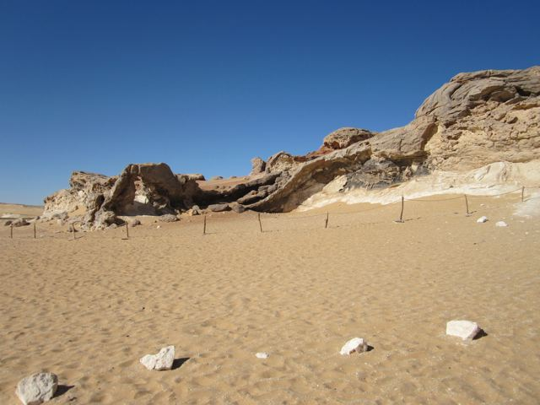 Crystal Mountain: Crystalline rock formations
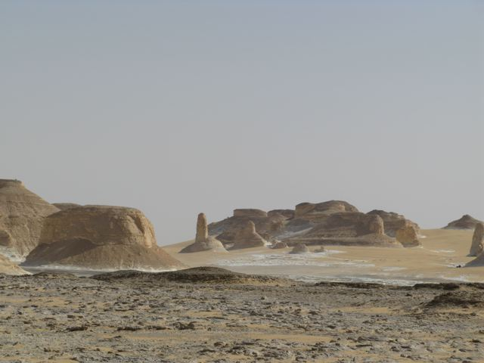 Agabat: Limestone mountains
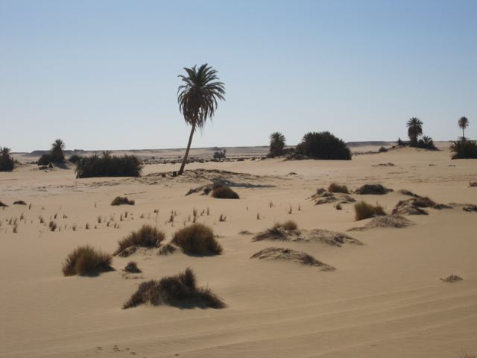 Wadi al Kebir: Big valley between Agabat and Ain Khadra
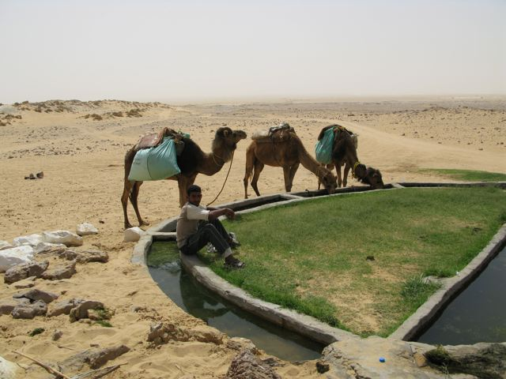 Ain Khadra and Ain Sirru: Two natural springs
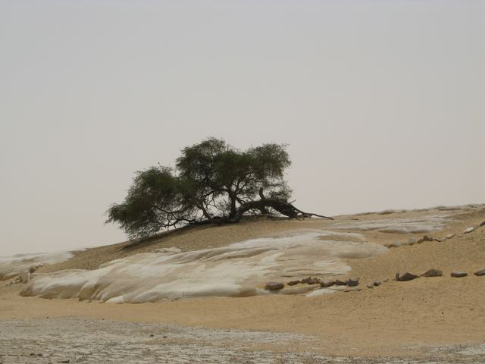 Santa: Very old acacia tree
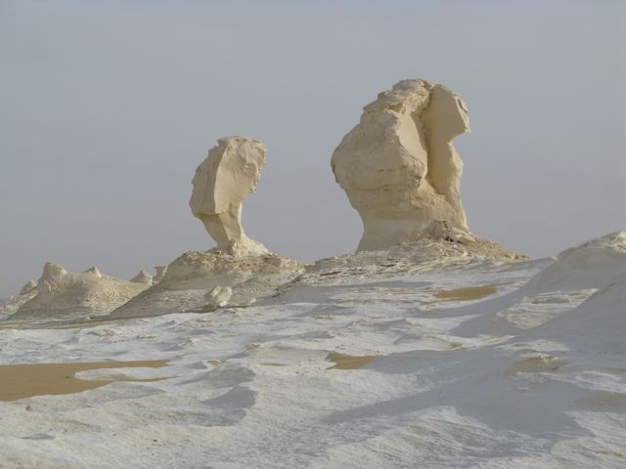 “Old” White Desert: Northern part of the famous white limestone formations
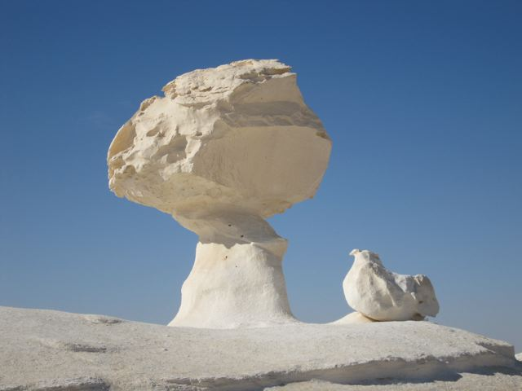 “New” White Desert: Southern part of the famous white limestone formations

7. WATERMELON VALLEY AND GARRA CAVE

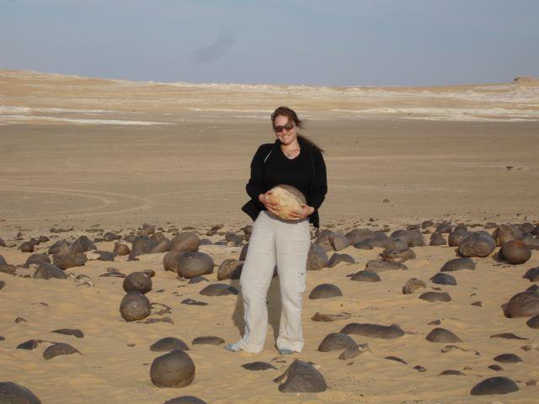 Watermelon Valley: Watermelon shaped stones
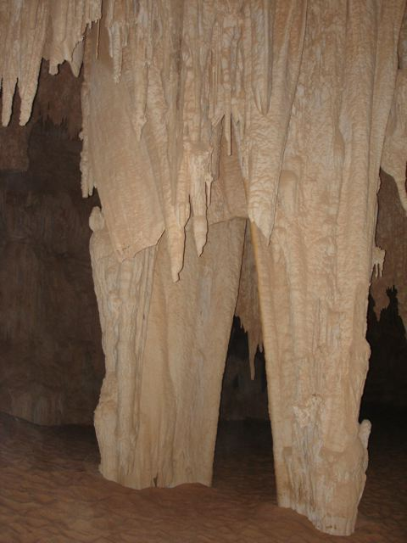 Garra Cave: Stalactite cave east of the White Desert

8. DAKHLA OASIS

Dakhla is the largest of all oases. It is intensely cultivated since ancient times.

Sightseeing

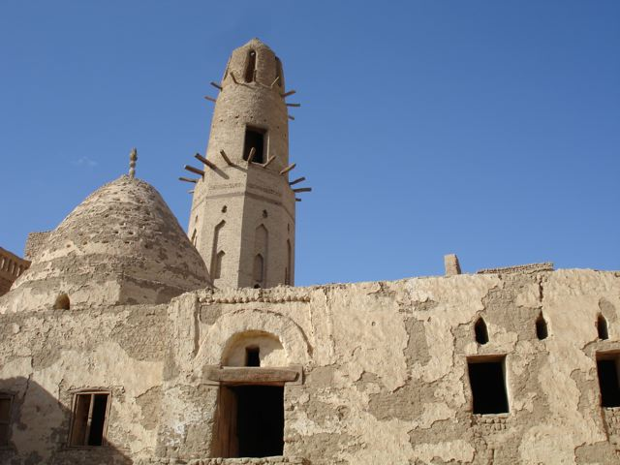 Al Qasr: Old Town of the Qasr village in Dakhla
Ethnographic Museum: About the oases of the Western Desert (located in a house in Al Qasr)

Balat Old Town: Old Town of the Balat village in Dakhla (similar to Al Qasr)

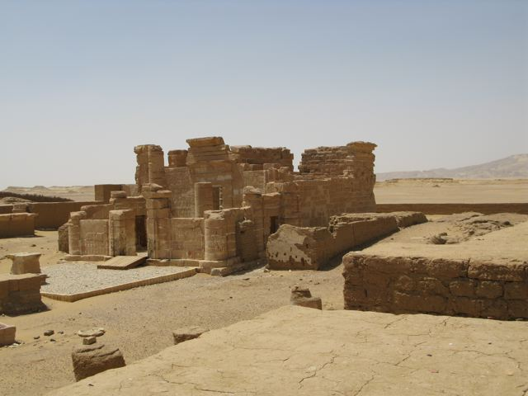 Deir al Hagar: Temple dedicated to Amun-Re, Mut, Khons (first century BC)
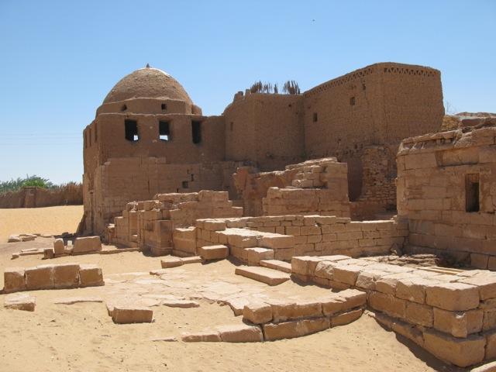 Beshendi Tomb and Tomb of Kitines: Tomb of a famous sheikh and a Roman tomb
(second century AC)

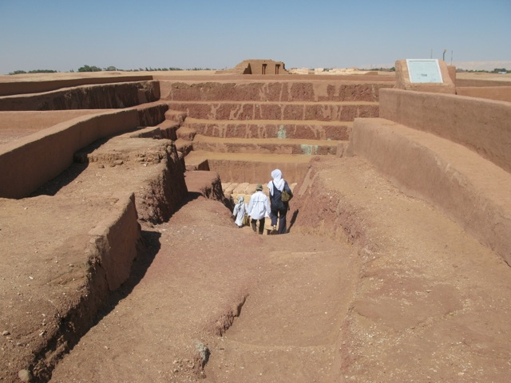 Qilat al Dibba Tombs and Ain Asil: Mastaba tombs and ruins of a village of the 6th dynasty

Muzawaqa Tombs: Greco-Roman necropolis (first and second century AC)

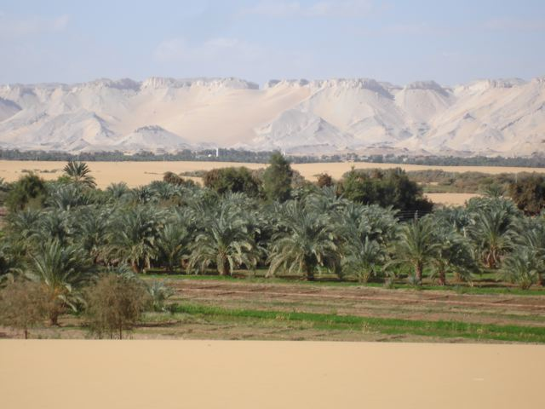 Gardens

9. KHARGA OASIS

Kharga is the administrative centre of the New Valley governorate and it is the most populated and modern oasis.

Sightseeing

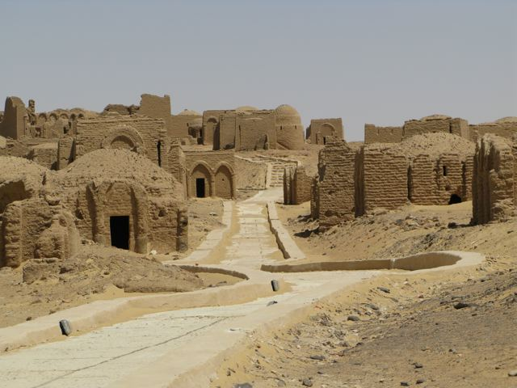 Bagawat: Christian Necropolis (3 - 6 century AC) with paintings
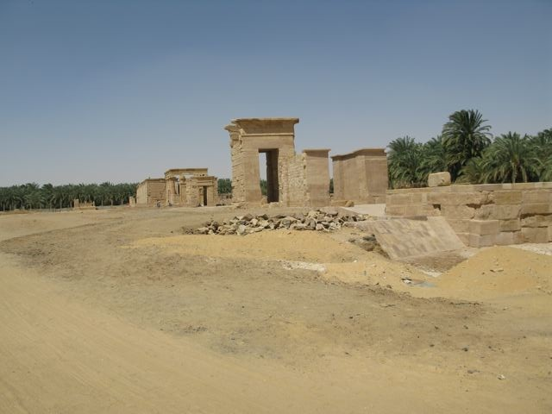 Hibis Temple: Largest temple of all oases dedicated to Amun of Hibis (26th dynasty)

Nadura Temple: Dedicated to Amun of Hibis (second century AC)

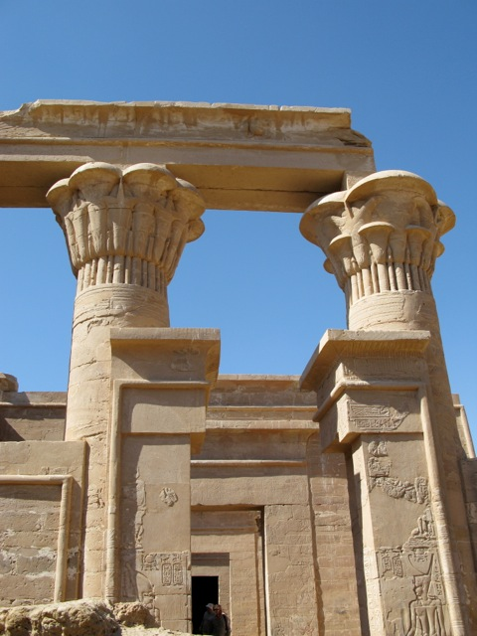 Ghuweita Temple: Dedicated to Amun, Mut, Khons (27th dynasty)
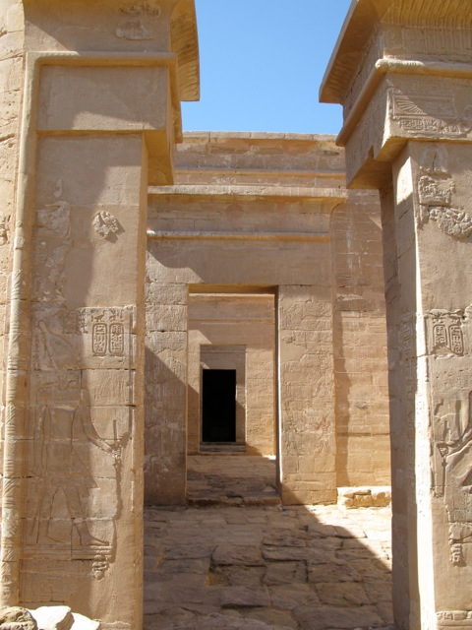 Zayan Temple: Dedicated to the local god Amenebis and Amun, Mut, Khons (4th century BC)

Dush Temple: Dedicated to Isis, Serapis, Horus (second century AC)

Baris Village: Small village in the south of the oasis with famous Haj Paintings

Kharga Museum: Artefacts found in the oases of the Western Desert

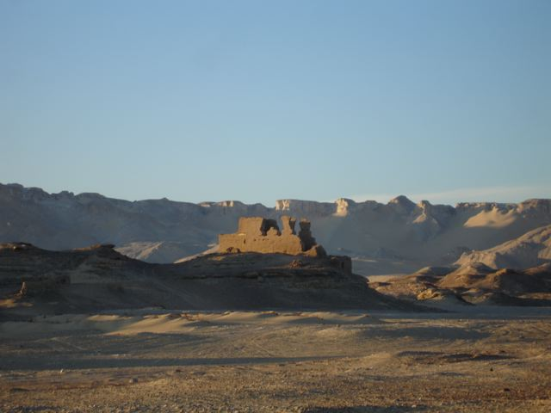 Ain Labakha: Ruins of a village of the Greco-Roman period including a castle and a temple
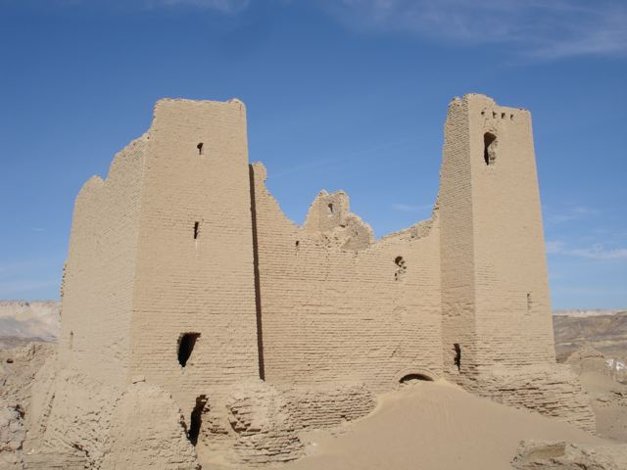 Um Dabadib: Ruins of a village of the Greco-Roman Period including a castle

10. GILF AL KEBIR
(see map “Gilf Al Kebir”)

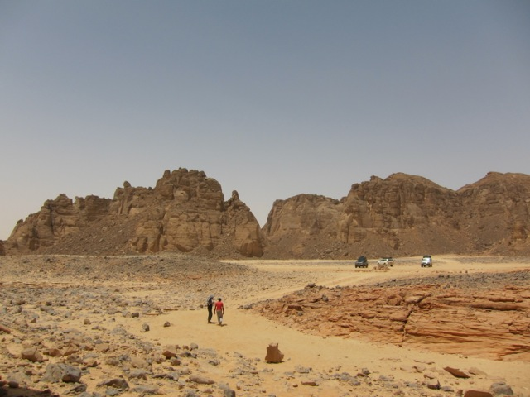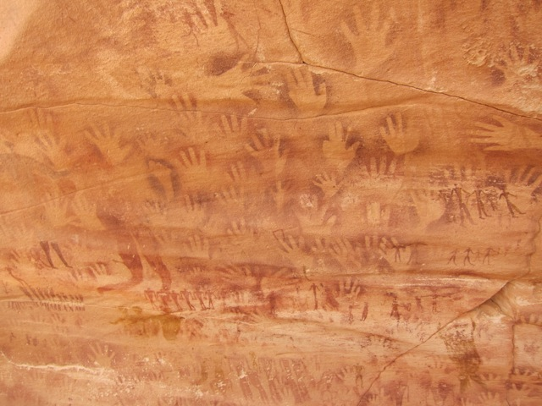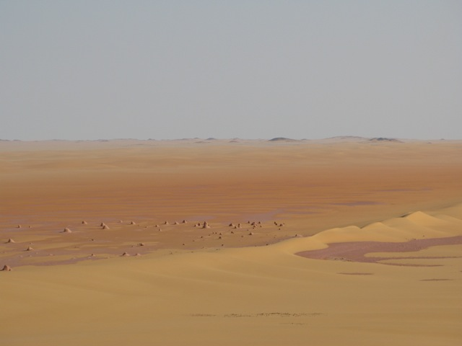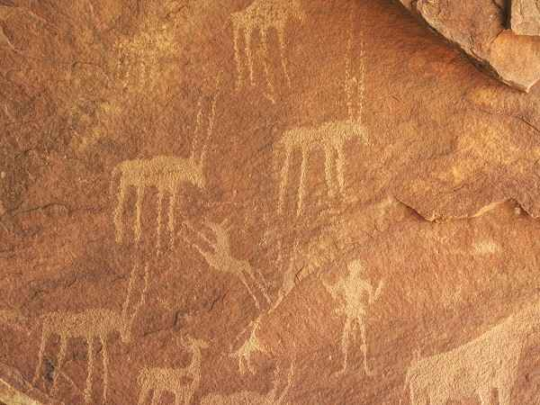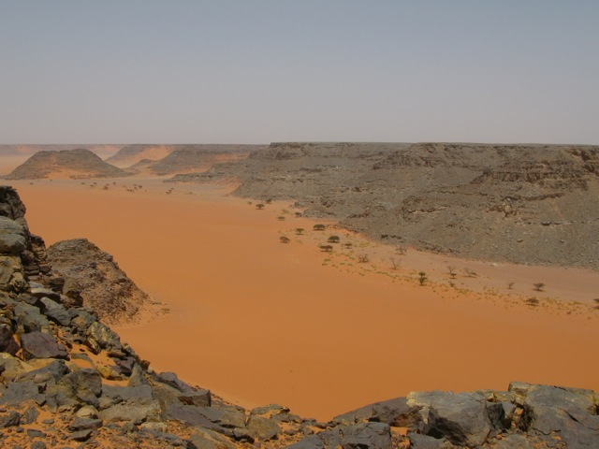

The Gilf al Kebir is a big plateau in the southwest of Egypt. Visiting this area is a big off road adventure tour far away from civilization including the following major spots: Abu Ballas (“Father of the pots”: Remains along an old caravan route), Wadi Mashi (“Valley of Walking”), Wadi Bakht (“Valley of Happiness”), Wadi Wasa (“Broad Valley”), Eight Bells (remains of an airport from the second world war), Memorial of Sultan Kamal ad Din (pioneer in the Gilf al Kebir), Karkur Talh (“Little valley of the acacias”) at the Gebel Oweinat (“Mountain of the Little Springs”) in the border region to Sudan and Lybia (prehistoric petroglyphs), Wadi Sura (“Valley of the picture”: prehistoric petroglyphs), Wadi Abd al Malik (“Valley of Abd Al Malik”), Wadi Hamra (“Red Valley”), Silica Glass Area (region with special stones probably as a result of a meteor crash in the sand).

